Eastway Middle School

Student Band Handbook

2021-2022
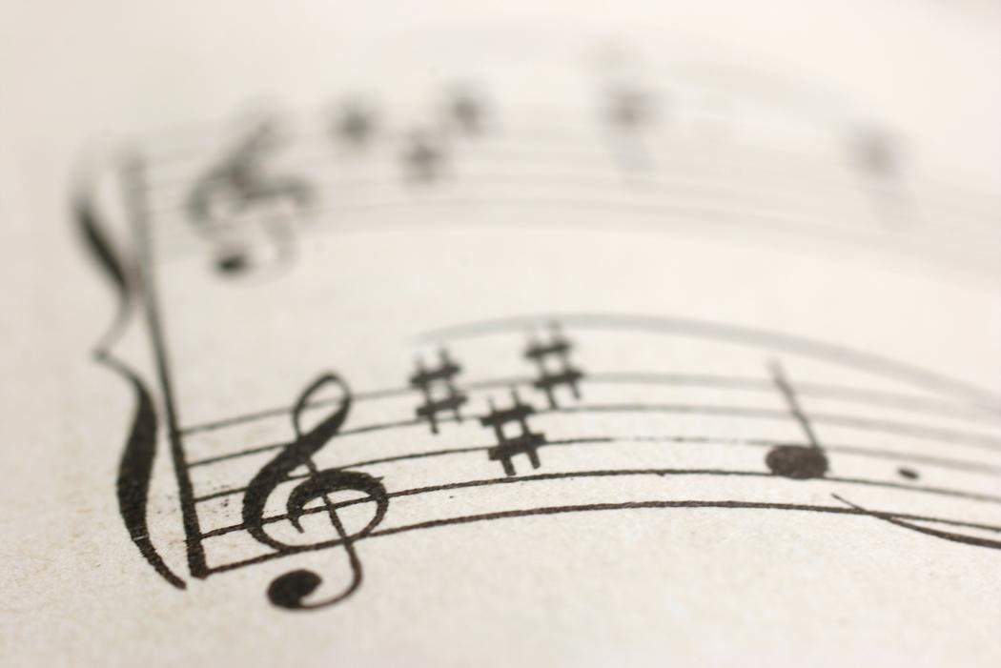

August 25, 2021

Dear Eastway Middle School Band Students and Parents,

Enclosed is the 2021-2022 Eastway Middle School Band Handbook. In this handbook you will read about the general goals of the Eastway Middle School band program, familiarize you with the policies, inform you of the rules and regulations of the program, and a list all performance dates for this year. I am very excited to begin the 2021-2022 school year with you. I am looking forward to working together, making great music, and providing amazing musical experiences and leadership opportunities with you, your peers, and our community. Let’s make this a wonderful year and create wonderful music together. Please take this opportunity to read through this handbook together.

**Please sign and return the last page by Friday, 8/27/2021 for a Prepare grade of 100%.

Sincerely,

Mr. Christopher A. D’Allura

Philosophy and Goals of the Eastway Middle School Band Program

Philosophy

For as long as people have been on earth, music has been a part of everyday life in every household and family. Society has placed music in a position where it is depended on in every aspect of daily life possible. In the history of our country, the growth of the quality of music programs in public schools is and has been essential. The continuing role of music education in public schools in the United States is essential to a happy and healthy community. Here at Eastway Middle School, music is a powerful means of developing other skills as well as good insight into a wide range of human emotions. It enriches the human spirit by allowing both the students and the educators to express their deepest inner feelings and emotions, which cannot often be put into words. Music is essential in making young people grow as musicians and as people with leadership skills. It is the responsibility of the staff and the music program to successfully allow the student body to grow as musicians and as people, also allowing them to realize their potential as musicians and most importantly, as leaders.

Goals (Begin with the end in mind!)

It is the goal of the Eastway Middle School music program:

- To develop the student’s musical skills through performing, listening and composing,
- To develop the student’s appreciation and value of good musicianship,
- To encourage the student’s understanding and adoption of the criteria for a well-run music program,
- To expose the students to a broad range of musical styles and genres,
- To enable the students to make music alone as well as with their peers and their teachers,
- To make the program enjoyable and productive for the student,
- Since Eastway is now a “Leader In Me” school, to set the students up for success in the future by basing instruction and expectations on Dr. Steven Covey’s “7 Habits of Highly Effective People”

Mission Statement

The mission of the Eastway Middle School band program is to bring out the leader in every student and make every student feel wanted, loved and important, even in ways that go beyond instrumental music.

Course Descriptions

6th Grade Band (Beginning):
This ensemble is designed to give students with little to no experience on their instruments, an opportunity to work in a large ensemble with students who are at the same level. The repertoire that is introduced in this ensemble is standard and on the beginners level, which go over the basic fundamentals of instrumental music. I will run this ensemble as a typical young middle school level band. They will have to work hard and spend time practicing at home, but at the same time, there will be that flexibility that one would find in a young ensemble. This ensemble will consist of the following:

- Daily rehearsals
- Music literacy on technology
- Daily written DO NOWS at the beginning of class
- A short “Leader in Me” lesson

7th Grade Band (Intermediate):
Students must have successfully completed 6th grade band or General Music to eligible for this class. This ensemble is designed to give students with a minimal amount of experience and an exceptional ability as well as experience on their instruments, an opportunity to work in a large ensemble with students who are at the same level in terms of experience and where the students sit in musical abilities. This ensemble is mainly designed to expose the students to a broad range of repertoire that will continue to sharpen their skills and will force them to enhance the fundamentals of their instruments at the middle school level. This ensemble will consist of the following:

- Daily rehearsals
- Music literacy on technology
- Daily written DO NOWS at the beginning of class
- A short “Leader in Me” lesson

8th Grade Band (Advanced):
Students must have successfully completed 6th/7th grade band or General Music to be eligible for this class. This ensemble is designed for more experienced players. In this ensemble, I will review the basics very quickly and I will introduce more advanced music. I will design this ensemble to prepare the current 8th grade students for high school. By the time they complete 8th grade, they will be more than ready to endure the challenges of participating in a band at the high school level. This ensemble will consist of the following:

- Daily rehearsals
- Music literacy on technology
- Daily written DO NOWS at the beginning of class
- A short “Leader in Me” Lesson

Policies, Rules and Regulations

All students of all ensembles are required to attend all concerts. If a student is not able to make a concert, the band director must be notified at least 24 hours in advance. Please refer to the grading policy on the next page for further information on concerts and rehearsals. The following schedule is when each class will meet during the week:

6th Grade Band: 4th Block on A days (1:00pm - 2:00pm)

Dress rehearsal for spring concert: TBA

7th Grade Band: 5th Block on A days (2:00pm – 3:00pm)
Dress rehearsal for winter concert: TBA

Dress rehearsal for Spring Concert: TBA

8th Grade Band: 2nd Block on A Days (10:00am – 11:00am)
Dress rehearsal for winter concert: TBA

Dress rehearsal for Spring Concert: TBA

Concert Dress Code:

The dress code for all performances consists of the following for all ensembles unless noted otherwise:

All band members: Band T-shirt and pants with closed toe shoes of choice! If they are jeans they may NOT be ripped!

*This year, there will also be opportunities for students to apply and obtain jobs in the band room. More details on jobs that will be available and eligibility to come!

Required texts and materials:

1. All students must bring a pencil to class every day.

2. Sound Innovations Book 1/2

3. A folder that will hold all music, scale sheets and other written assignments.

4. A notebook of any kind for written assignments in class.

5. Chromebook

Rules of the Band room
- Be respectful!
- Raise your hand!
- Take care of the equipment!
- Keep the Band room clean!
- Do not disrupt the class!
- Think and speak positive words!

As soon as I approach the podium, you must be ready to play, with your pencils out, your instruments assembled, your music out, and your music in rehearsal order that is written on the board.

Daily Expectations of the Band Room

- Enter quietly!
- Complete the DO NOW!
- Assemble your instruments in a timely manner!
- Stay on Task and stay focused!
- NO CELL PHONES DURING INSTRUCTION!
- Pack up when told to do so!
- Always give it your best!

When class is over:
- Pack up when asked to do so. (You will be called on by sections)
- Pick up all trash underneath and around your seat, even if it’s not yours!
- The students who are sitting nicely and quietly will be the first to dismiss.

Please see the behavior matrix for the discipline steps that will be taken!

Seating Audition Rubric

Name: ______________________ Date: _____________ Grade: _____ Block: _____

Instrument: ______________________________
 | 1  Does Not Meet Expectations | 2  Below Average | 3  Average | 4  Above Average | 5  Exceeds Expectations
Note Accuracy | - Many mistakes  - Cannot finish | - 4+ mistake  - Many restarts | - <4 mistakes  - Some restarts | - 1-2 mistakes  - No restarts | - No mistakes
Intonation | - Very out of tune playing | - Somewhat in tune  - Uneven pitch | - Mostly in tune  - Pitches are relatively accurate | - In tune playing with few pitch errors | - No pitch errors
Tempo/Rhythm | - Cannot feel the beat or say the rhythm | - 4+ mistakes  - Unsteady tempo | - <4 missed rhythms  - Unsteady tempo | - 1-2 missed rhythms  - Tempo is slightly irregular | - Steady tempo  - No rhythm mistakes
Tone | - Very quiet playing  - Unsteady tone | - Muffled tone | - Somewhat unsteady tone | - Steady tone | - Very Steady Tone
Musical Expression | - Dynamics and breathing or sticking are ignored | - Some dynamics  - Some breathing/ sticking observed at phrase endings | - Dynamics and breathing/sticking usually observed | - Good dynamics  - Proper breathing/ sticking used | - Excellent dynamics and sticking/  Breathing  - Appropriate notes  emphasized
Performance | - Many problems with:  -Body position  -Hand position  -Attitude | - Some attempt to use good posture, hand position, and attitude | - Excellent attempt to use good posture, hand position, and attitude | - No problems with:  -Body position  -Hand position  -Attitude

Grading Policies

The following grading policies are essential to the students’ progress in the course:

You are responsible for attending all performances for the year, unless you let me know at least 24 hours in advance, with a written note. The concerts are worth three test grades (Attendance and behavior at the concert/dress rehearsals, and post-concert assignment). Here is the grading scale that will be followed:

Prepare - 20% (Homework, DO NOWS, Exit Tickets)
Rehearse - 30% (quizzes, classwork and participation)
Perform - 50% (Formal assessments, playing assessments, projects and concerts)
A: 90-100
B: 80-89
C: 70-79
D: 60-69
F: 0-59
90-100 – A

80-89 – B

70-79 – C

60-69 – D

0-59 – Failure

For all ensembles:
*For every UNEXCUSED absence from a concert, you will receive at least 2 written test grades of a 0!

***For every tardy WITHOUT A PASS, you will lose ten (10) points off of your participation grade.

**** For every time you are not prepared for band (not having your instrument) you will lose five (5) points off of your participation grade. This year, instead of 2 participation grades per quarter, you will receive one at the end of every week! FOR EVERY DAY YOU ARE NOT IN CLASS, YOU WILL LOSE THE ALLOTTED AMOUNT OF POINTS FOR THAT DAY, DEPENDING ON HOW MANY DAYS YOU HAVE BAND THAT WEEK! IF YOU ARE ABSENT DUE TO ILLNESS OR FAMILY REASONS, IT IS YOUR RESPONSIBILITY TO LET ME KNOW THAT SO WE CAN WORK OUT A WAY TO GET YOU YOUR POINTS BACK!

Scale Expectations

****For 6th Grade Band: In this class, we will learn 3 major pentatonic scales (Bb, Eb and F). You will be required to have all of them memorized by the end of the year. These scales will be a part of your practice materials and you will be tested on them, so make sure you review them every night you practice!

****For 7th Grade Band: In this class, we will learn 3 major full octave scales (Bb, Eb and F). You will be required to have all of them memorized by the end of the school year. These scales will be a part of your practice materials and you will be tested on them, so make sure you review them every night you practice!

****For 8th Grade Band: In this class, we will learn 6 major full octave scales (Bb, Eb, Ab, F, C and G). You will be required to have all of them memorized by the end of the school year. These scales will be a part of your practice materials and you will be tested on them, so make sure you review them every night you practice!

Calendar of Events

****Dates for seating auditions will be determined in November.

TBA: 7th and 8th grade winter concert at 5:30pm

TBA: 6th - 8th Grade Spring Concert/International Night at 5:30pm

***Any other performances and activities will be posted on a later roster.

Performance & Rehearsal Etiquette

As we begin to go out into the public, we need to be aware of some behaviors that we must keep in check. It is our obligation to our audiences, and those we work with to act and behave in a professional manner.

- Volume: Great for forte music; however, not great when others are performing and we are the audience members. It is also not necessary to be loud when we are entering and exiting buildings, rehearsals, or any other times when we are in public.

- Rehearsal: Listen to the conductor or whoever is giving directions. Do not be rude, talk, nor do other things while the rehearsal is taking place.

- Waiting to Perform: While we are waiting to go on stage or listening in the audience, please be aware that sound travels.

- Performing: Do not talk to your neighbor on stage, giggle, be silly, or any other behavior that looks unprofessional. We are a professional performing organization, and that needs to be reflected on stage. Do not wave to family or friends in the audience. If we make a mistake, do not let the audience know. Finally, do not play with your music or talk while the audience is applauding; it is rude to them, and plus, we want to get as much applause as possible!

- Remember our Mission: Set the tone for Eastway and LEAD BY EXAMPLE! Show the community that you are a leader!

August 25, 2021

Dear Parents:

The purpose of the handbook is to present the general goals of the Eastway Middle School band program, familiarize you with the policies, rules and regulations of the program and list all performance dates for the year. (The complete list of ensemble performances will be sent home at a later date.) The Eastway Middle School band program offers both the students and the parents, exposure to a broad range of experiences and opportunities of musical interest. The program is designed to help the students explore and pursue his/her area of interest: specifically, the instrument of their choice. Please take some time to read through the handbook and discuss the content of it with your child. Then, please sign and return the bottom portion of this letter (please make sure that your child has signed it as well). This must be returned by Friday, August 27th 2021. Marking the performance dates on a calendar at home is highly recommended to avoid any other conflicts. If you have any questions or concerns, please do not hesitate to call or text me (567-644-9093) or email me (christophera.dallura@cms.k12.nc.us).

Sincerely,

Christopher A. D’Allura

......................................................................................................................................................

Together, we have read and understood the contents of the 2021-2022 Eastway Middle School Band Handbook.

__________________________________ ___________________________________
Parent Signature Date Student Name (please print) Date

***This must be returned by Friday, August 27th***

